County, Peons
GEORGE N. ZANICANGELA J.ROBINSON
PRESIDENT JUDGECOURT ADMINISTRATOR
STEWART L. KURTZ | Court of Common Pleas | STEPHANIE J. SMITH
SENIOR JUDGE | 20th Judicial District  223 Penn Street  Huntingdon, PA 16652 (814) 643-5078 www.huntingdoncountycourt.net | DEPUTY COURT ADMINISTRATOR

Language Access Coordinator, Angela Robinson LAC@huntingdoncoun!y.net
LANGUAGE ACCESS PLAN

Section I. Introduction and Purpose
Equal access to the courts is fundamental to the legitimacy of our system of justice and the trust and confidence of Pennsylvanians in our courts. Language services for individuals who are limited English proficient (LEP) or are deaf or hard of hearing are essential to ensure that they are able to fully participate in judicial proceedings and court services, programs, and activities in which their rights and interests are at stake. Without these services, they are effectively denied the protection of our laws. Moreover, the courts themselves have an independent interest in ensuring the integrity of communications with LEP and deaf or hard of hearing court users so that the fact finder can hear evidence accurately and deliver justice fairly.
The policy of the Unified Judicial System is to provide meaningful language access for all individuals who are LEP to ensure that all persons have due process and equal access to all judicial proceedings, court services, programs and activities. Ensuring meaningful language access means providing timely, accurate, and effective language services at no cost to the court user.
In addition, it is the policy of the Unified Judicial System to provide equally effective communication to individuals who are deaf or hard of hearing, in part, by providing American Sign Language interpreters at no cost to litigants, witnesses and court spectators.1
Pennsylvania's policies regarding language access to the courts are embodied in the Language Access Plan for the Unified Judicial System (LAP-UJS). This plan was approved by the Pennsylvania Supreme Court in March 2017. The LAP-UJS policies and requirements, which are binding on the judicial districts, are incorporated herein by reference. The LAP-UJS is available at languageaccess.pacourts.us.
The judicial district has appointed a language access coordinator who can be reached at LAC@huntingdoncountycourt.net.

¹ See, Language Access Plan for the Unified Judicial System of Pennsylvania at 2, available at http://languageaccess.pacourts.us.

Section Il. Legal Basis
The legal basis for this Language Access Plan is set forth in the LAP-UJS Title VI of the federal Civil
Rights Act of 1964, Section 504 of the Rehabilitation Act of 1973, and the Americans with Disabilities Act at the federal level, and the Pennsylvania Interpreter Act and regulations pursuant thereto at the state level.

Section Ill. General Principles of Language Access
General principles of language access are referenced in the LAP-UJS. Significant principles include the following:
- Courts are responsible for early identification of the need for language services, including, among other things, providing timely and effective notice to those in need of such services.
- Interpretation and translation must be provided by the court at no cost.
- Persons who request language access services should be provided with them, in accordance with Title VI of the Civil Rights Act and the Pennsylvania Interpreter Act.
- Language access services should be offered, even if not requested, where the need is apparent or where the ability of a person to understand and communicate in English is unclear.
- Individuals who are LEP, deaf, or hard of hearing should never be expected to use informal interpreters, such as family members, opposing parties, or their counsel, nor should courts allow them to be used.
- Having an in-person interpreter for judicial proceedings is the most effective method to ensure effective communication for LEP court participants and is strongly preferred under the law. Remote interpretation through audio-visual technology, use of Video Remote
Interpreting ("VRI") or telephone is permitted only in limited circumstances, as set out in the Pennsylvania Interpreter Act regulations.
- Courts must provide interpreters in a timely manner.
- Courts must provide meaningful language access to court users who are LEP, deaf, or hard of hearing in all services, programs, and activities of the courts. This means access must be provided in judicial proceedings (both criminal and civil), and for the general business of the courts.

Section IV. Language Needs of this Judicial District
Based on Language Access Data Collection information for 2020, below are the top 4 languages (including American Sign Language) for which interpreters were most frequently requested in this judicial district:
- Spanish
- American Sign Language
- Russian
- Chinese 5.

Section V. Language Services and How to Use Them
A. Oral Language Services
- Interpreters
[X This judicial district provides interpreters for judicial proceedings in compliance with the rules and policies set forth in the Pennsylvania Interpreter Act and regulations, the AOPC Interpreter Certification Program regulations,⁴ and the Guidelines for the Procurement and Appointment of Interpreters issued by the AOPC. These policies require the District to provide court interpreters to all LEP and deaf or hard of hearing parties, victims, witnesses, and certain other persons for any civil or criminal proceeding.
[X The judicial district provides court users with the interpreter request and waiver forms available on the Interpreter Certification Program page of the UJS website.
Xl We post interpreter request and waiver forms on our website.
- Bilingual Staff
This Plan hereby incorporates by reference the Bilingual Employee Policy issued by AOPC on September 28, 2018, and reissued as amended on December 20, 2018. The policy became effective on January 1, 2019.
Under the policy, current employees of the UJS who are bilingual and intend to continue to use their bilingual skills to assist limited English proficient and deaf and hard of hearing members of the public must be tested and achieve a passing score, as defined by the policy, by January 1, 2021. Employees hired after January 1, 2019, who intend to use their language skills to assist LEP and deaf and hard of hearing members of the public must be tested and achieve a passing score as defined by the policy before they can utilize their skills to assist members of the public.
This judicial district has taken the following steps to implement the Bilingual Employee Policy:
Cl (a) We have incorporated testing of bilingual employees into our hiring process for new employees who will use their bilingual skills to assist members of the public as a part of their jobs.
(b) We have informed employees hired before January 1, 2019, who use their bilingual skills to assist members of the public that they will need to be tested by their judicial districts and achieve a passing score as defined by the policy by January 1, 2021, or no longer use their bilingual skills as a part of their job.
Cl (c) Bilingual employees and their supervisors have viewed the AOPCproduced training, available at https://www.youtube.com/watch?v=yuJP7e znOU.
We have not taken the above-listed actions, but intend to complete each step by the following dates.
- Testing of bilingual employees will be incorporated into our hiring process by [insert date].
- Bilingual employees will be informed that they will need to be tested by the judicial district and achieve a passing score as defined by the policy, or no longer use their bilingual skills as a part of their job by [insert date].
- The above-referenced AOPC-produced training video will be viewed by bilingual employees and their supervisors by [insert date].
Xl We do not have any bilingual employees. Therefore, we will utilize in-person interpreters where available and will utilize telephone interpreting in compliance with Section 104 of the Regulations pursuant to the Pennsylvania Interpreter Act.

B. Written Language Services
1. Court Forms and Documents
This Plan hereby incorporates by reference the principles and translation protocol set forth in the AOPC Translation Policy & Procedures Manual of the Unified Judicial System.
This District has reviewed the UJS Translation Policy and Procedures Manual and follow the guidelines for high quality translation established therein.
This District plans to take or has taken the following steps explained in the Translation Manual to prioritize further translation work within the time periods specified:
Create a spreadsheet with an inventory of all district forms, documents, orders, signs, web content, etc. by July 1, 2022.
Perform the two-step analysis of each writing set forth in the Translation Policy & Procedures Manual to determine if it is a vital document, with results listed in the spreadsheet by July 1, 2022.
El Assign each document to a priority group for translation by July 1, 2022.
[X Create a tracking system to record translations by July 1, 2022.
Cl Translated forms currently available to court users in this District include the following (languages into which forms are translated and their location in the courthouse or on court website are indicated next to its name in parentheses):
Translated documents have been integrated in this judicial district's case management system in the following fashion:
C] The translations in the above list have been completed for the languages listed in Section IV above (top languages for which interpreters are most frequently requested in this judicial district) or should be completed by [insert date].
This judicial district uses the translated forms made available to the courts by the
Administrative Office of Pennsylvania Courts (AOPC).
2. Signage & Websites
While acknowledging that the counties in which judicial districts are located generally own the courthouse buildings and control signage, this judicial district has taken the following steps towards incorporating bilingual signage into its court buildings and has done the following to address translation of court websites:
C] We have incorporated bilingual or multilingual signage into our existing court buildings as follows:
We have recently renovated court buildings and taken the opportunity to incorporate bilingual or multilingual signage into our renovated or new buildings as follows:
X] We are planning to include bilingual or multilingual signage in our buildings in this way by new signage after courthouse renovation.
We have planned a courthouse 2nd floor renovation in the future. This will require all new directional and office signage. At the time when we are updating all of our signage, we will implement bilingual or multilingual signage for the court. For the office that will not be affected by the renovation signage, I will make a recommendation to the commissioners that this signage be updated to include bilingual or multilingual signage. Signage in both English and Spanish will be my recommendation. Expected renovation begin date is 2022/2023.
El We have reviewed our court website with an eye to translating webpages in subject matter areas in which our judicial district experiences high LEP usage.
Cl We have translated the following pages using qualified translators:
Xl We intend to translate the following pages by [July 2022] using qualified translators:
I will contact the vendor that handles the court website and ask for recommendation on web page translation.
C. Use of Remote Technology
[X The judicial district has contracted with Language Line Services, Inc. to provide telephone interpreting services, primarily for counter communication with LEP court users.
Instructions for contacting a telephone interpreter have been posted and distributed to all staff who interact with the public.

D. Language Access to Services, Programs, and Activities Outside the Courtroom
Language access requirements apply not only to judicial proceedings, but also to a wide range of services, programs, and activities outside the courtroom that are administered under the authority of the court, i.e., provided by or contracted for by the court.
Meaningful access to services outside the courtroom is a vital component of equal justice for LEP and deaf or hard of hearing persons. Examples of court services outside the courtroom include the following if administered under the authority of the court: services of the domestic relations office, the juvenile and adult probation offices, pro se clinics, some Alternative Dispute Resolution programs (ADR), family court custody education and mediation programs, drug and alcohol evaluation and treatment, mental health evaluation and treatment, anger management classes, domestic violence programs, safe driving classes, and other diversionary and educational programs.
Listed below are services provided by or contracted for by this judicial district, and the methods through which language access is provided for these services. If other services or programs are provided, list them with the language service information below the chart. Check all that apply, unless not applicable (N/A) is checked:
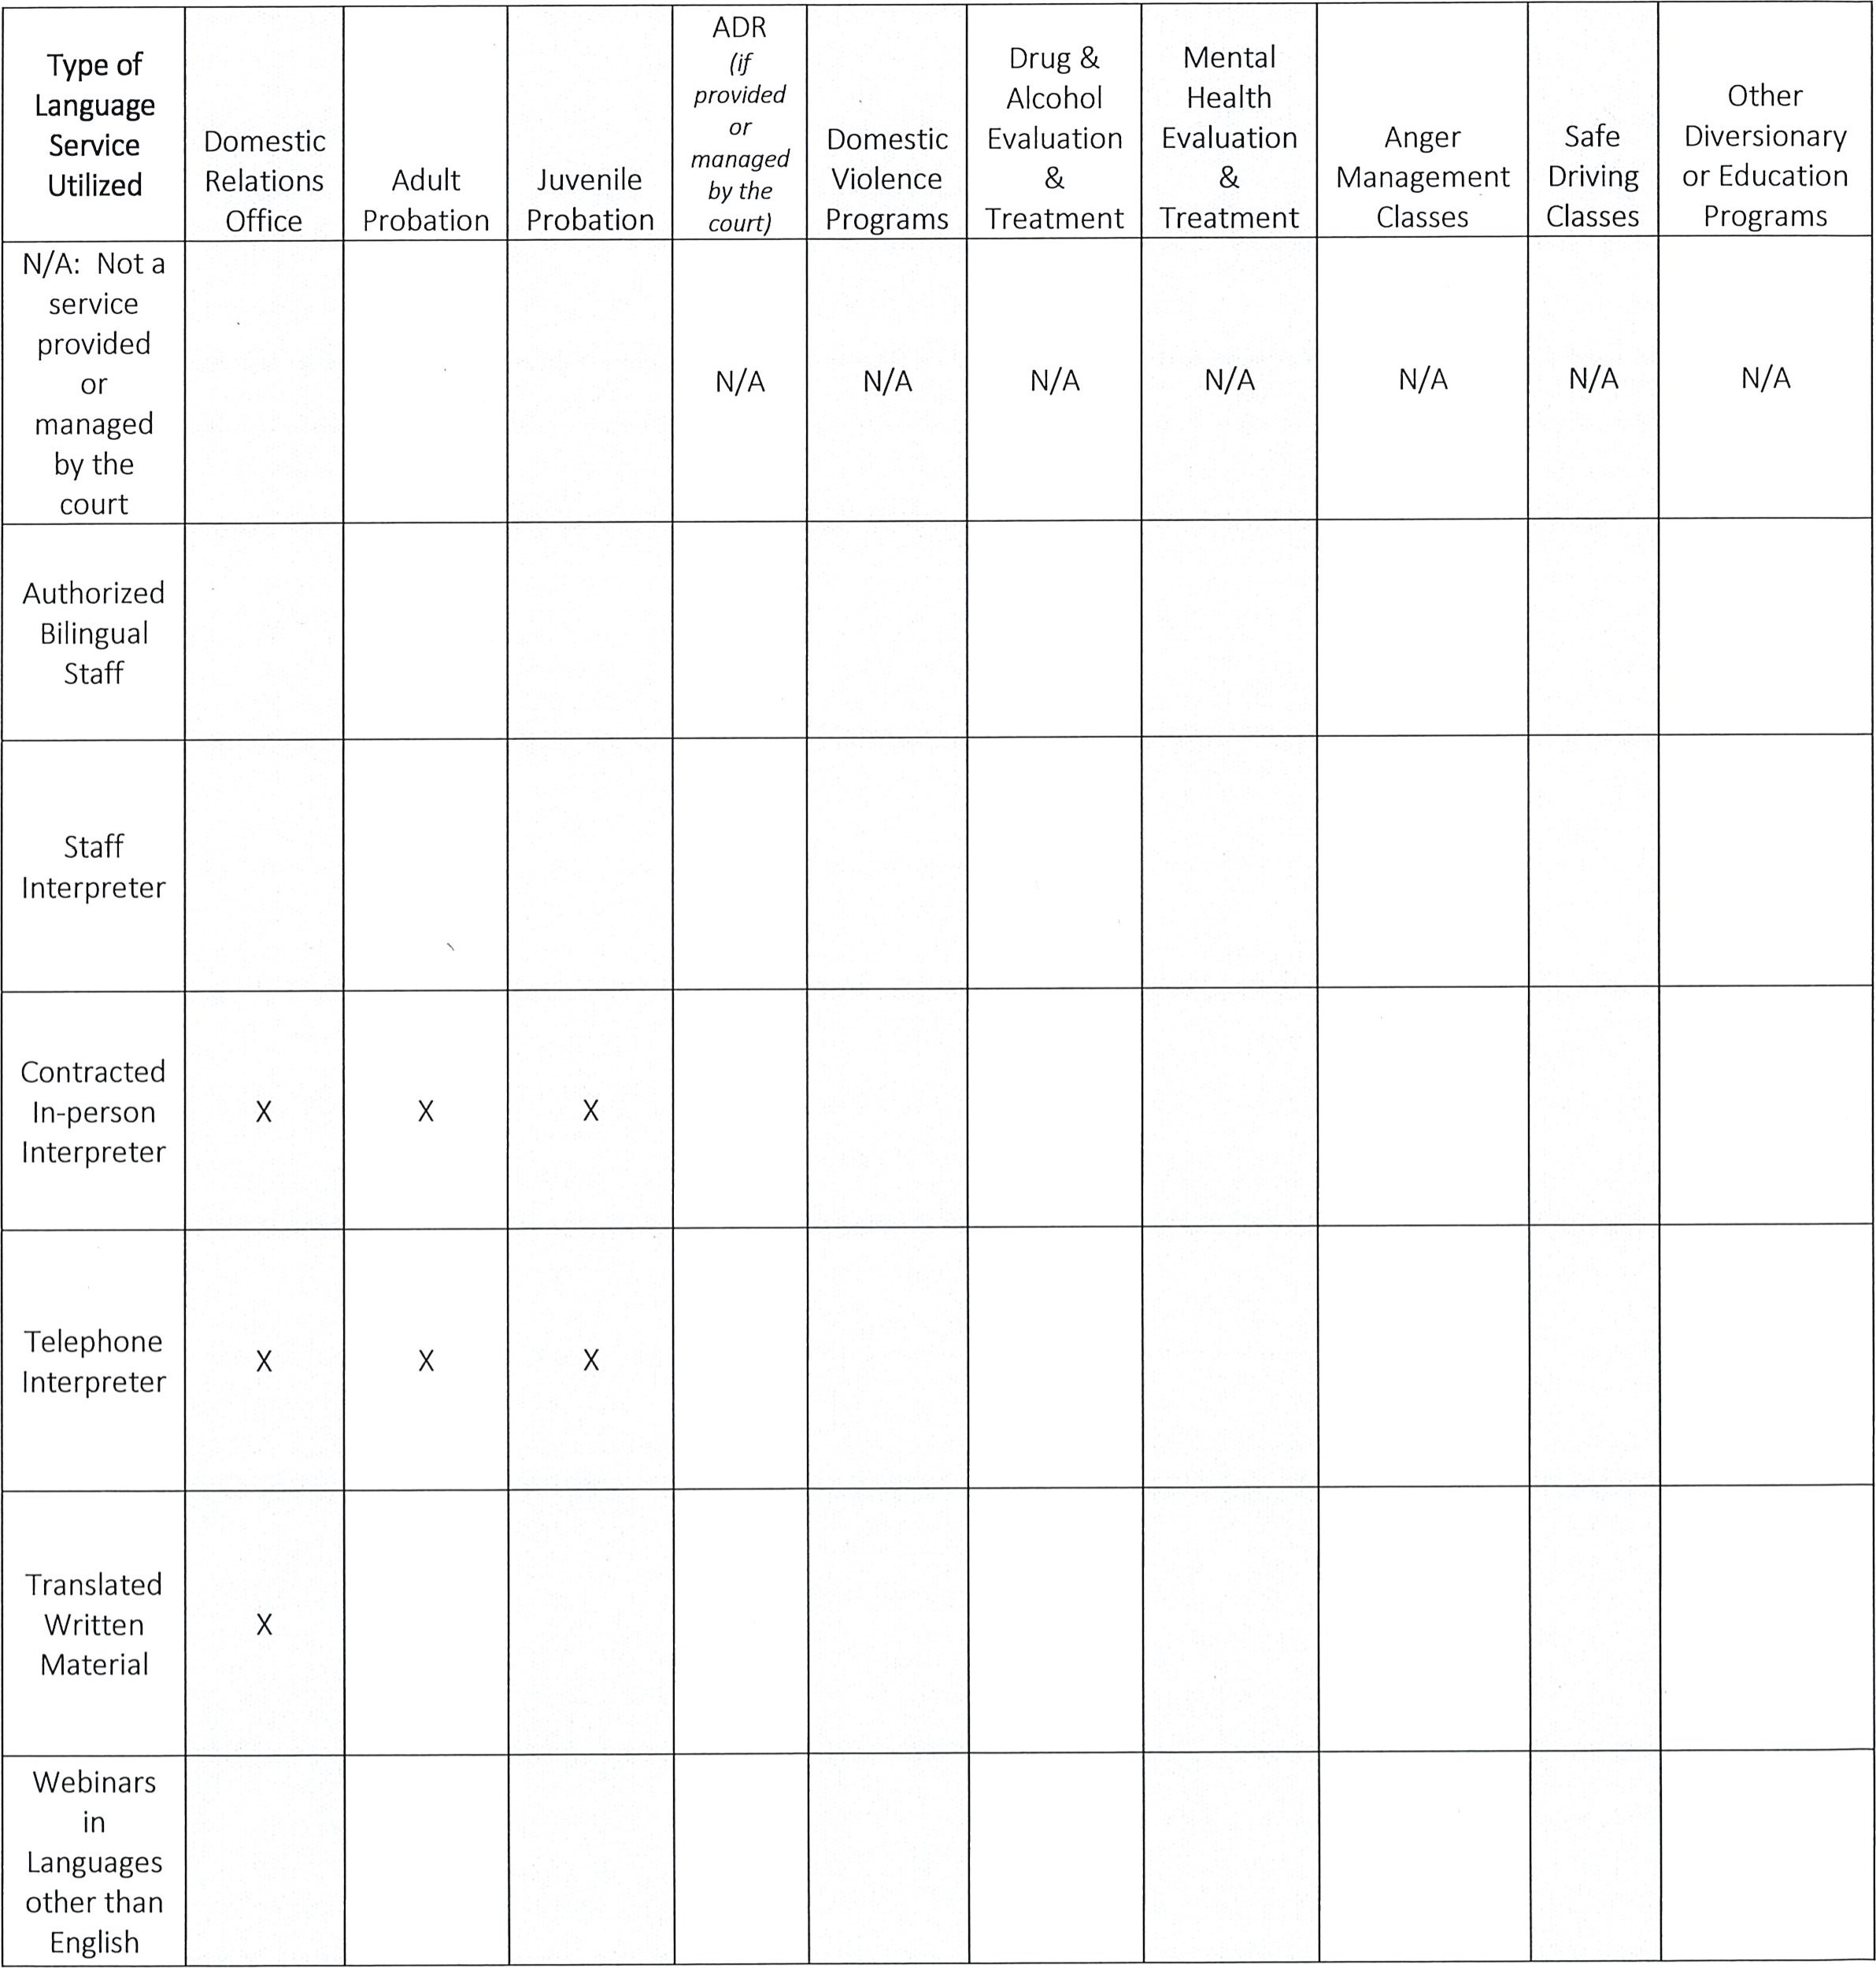
In many judicial districts certain court programs and services are provided by private, third party vendors under contract with or paid by the court. Judicial districts are responsible to ensure that meaningful access is provided to LEP persons by vendors of these services and should review and seek adjustment of contract terms accordingly.
In addition, the judicial district is working with the vendors with whom it contracts to provide programs to ensure that those vendors comply with Title VI, the Americans with Disabilities Act, and the Rehabilitation Act of 1973. Specifically, the district includes the following provisions in its contracts with vendors and has encouraged the county to do so, as well, in its contracts with vendors that provide court programs and services:
[X The judicial district has not yet worked to include language in vendor contracts requiring compliance with Title VI, the Americans with Disabilities Act, and the Rehabilitation Act of 1973. The district intends to accomplish this by this date: December 31, 2022.
Xl In addition, the Language Access Coordinator and/or DCA for the judicial district have advised judges that they should consider the ability of an LEP litigant to complete a given program before ordering him or her to do so, and have advised judges that they should not put an LEP litigant in danger of being held in contempt, charged extra fees or costs, or subject to any other adverse consequence for failure to complete a program that did not provide competent interpretation and translation.

Section VI. Early Identification of the Need for Language Services

1. Advance Notice
The judicial district informs individuals of their right to a sign language interpreter and language services using the following forms of notice and in the manner specified below:
A Notice of the Right to Language Services (hereafter "NLR") in English and in no fewer than the five most commonly spoken languages in the judicial district, providing a phone number to call as well as an email address where a request for an interpreter may be sent. The NLR is provided in the following fashion:
[X Automatic printing of the standardized AOPC-provided NLR for hearing notices and subpoenas generated by MDJS and CPCMS.
[X An abbreviated NLR in this judicial district's 5 top languages in addition to English, approved by AOPC, and appearing on the back of our envelopes.
explained
below:
El Notice of Language Rights and the appropriate contact information for requesting an interpreter is included on all court brochures and informational materials.
Our judicial district will make the UJS language access brochure available on our website.
[X Notice of Language Rights and the appropriate contact information for requesting an interpreter is posted on the court's website at this link:

https://huntingdoncountycourt.net/forms/
[X AOPC Right to Interpreter posters are placed prominently and in close proximity to court or court office staff in:
[X All CCP court or court office reception/information desks or kiosks [X MDJ courts and court offices [3 Other locations:

[X "I Speak" cards in the five most common languages spoken in the judicial district, as well as a card in English for deaf or hard of hearing persons are placed prominently and in close proximity to court or court office staff in:
All CCP court or court office reception/information desks or kiosks
MDJ courts and court offices Other locations:

In addition to the above-described methods, the judicial district intends to provide Advance Notice in the following ways, and/or intends to do so by the dates indicated below:

2. System for Receiving and Processing Requests for Language Services
Xl The judicial district has language services in place to receive and respond to requests for language services to LEP persons who contact court staff to inform them of their need for language services.
[X These services are available in the following methods of communication:
[X In person
[X By phone
Email
El Website
Mail

Section VIl. Keeping Data on the Need for and Use of Language Access Services
Xl In compliance with the LAP for the UJS, this judicial district inputs all data regarding use of interpreters and provision of other language access services into Language Access Data Collection ("LADC"), the statewide system for tracking this data.
El In addition, this judicial district utilizes the "special consideration" feature in MDJS and CPCMS to indicate the need for an interpreter for cases in those systems.
[Xl The judicial district uses the following system to mark case files and scheduling documents with an "interpreter needed" designation, so that there is an automatic mechanism to trigger arrangements for an interpreter throughout the life cycle of a given case. Please describe below what system this district is using:
Mark scheduling documents both paper copies and computer records.

Section VIll. Training & Continuing Education
The judicial district will work with the AOPC to ensure that all employees are trained on appropriate provision of language access services. Judicial district staff will attend training to assist them to: identify and respond to LEP persons, increase awareness of the types of language services available, guide when and how to access those services, and effectively use language services, how to handle issues such as stress and frustration with being unable to communicate with someone who is deaf or hard of hearing, and procedures for receiving both informal feedback and formal complaints. New employees, especially those who will have regular contact with the public, will be required to attend language access training.
All current and new judicial district staff will attend, and county clerks will be offered, the following training regarding language access:
[X Taped training developed by AOPC, available at https://youtu.be/FObgm-ewIw4.
For newly hired and current bilingual staff and their supervisors, the taped training developed by AOPC, available at https://www.youtube.com/watch?v=yuJP7e znOU.
Interpreters new to our judicial district receive an orientation to local judicial district processes and procedures via the following means:
C] We send them a standard email with information about our policies and procedures, attached hereto.
We utilize the Local Court Interpreter Orientation Checklist created by AOPC.
[X We meet with new interpreters before their first appearance in our court, and provide them with basic information about our policies and procedures.
[X We orient interpreters new to our courthouse in the following fashion:
Meet with interpreters in court administration before first scheduled appearance to answer questions and give a tour of our facility.
In addition, this judicial district provides the following training on language access:
[X Periodic training for new judicial district staff
[X Periodic training for employees who have frequent contact with the public
Cl Language Access Basic Training, online training by New Mexico Administrative Office of Courts, available at https://www.nmcenterforlanguageaccess.org/lafund/#/.
[3 Other [please describe]:

IX. Outreach to Court Users and Communities
The judicial district consulted with the following community members in creating this LAP:
[X Jeffrey Leonard, Sheriff of Huntingdon County
[X John Chris Stevens, Huntingdon Borough Manager
Jeffrey Buckley, Huntingdon Borough Police Chief
Upon AOPC approval of the LAP:
El The judicial district will post its LAP on its public website and/or public notification area within the courthouse and will make copies of the LAP available upon request.
In addition, copies of the plan have been provided to all identifiable stakeholders in the LEP and deaf/hard of hearing communities, including but not limited to: the District Attorneys' Office, the Public Defenders' Office, the local legal aid office, local domestic violence or sexual assault programs, and any local agency that serves limited English proficient or deaf or hard of hearing individuals.

Section X. Monitoring and Evaluation of Language Access Plan: Complaint/Feedback Procedure
X] The judicial district will review this LAP annually to assess whether it needs to be updated. The LAP will remain in effect unless modified or updated.
[X The judicial district's review shall include the following areas which may indicate a need to update the LAP:
o Increase in number of LEP and/or deaf or hard of hearing persons requesting court interpreters or language assistance º Funding provided or available for languages services o Current language needs to determine if additional services or translated materials should be provided o Feedback from LEP and deaf or hard of hearing communities and stakeholders within the judicial district o Court staff (turnover, new hires, etc.) o Feedback from trainings provided by the judicial district or AOPC o Viability of identified language services and resources o Problem areas such as improper denial, delay, or poor quality language assistance and corrective action strategies o Updated census data
[X The language access coordinator for this judicial district ensures this plan is followed, advises the court on potential updates to this plan, and coordinates provision of language access services for the judicial district as they arise.
The language access coordinator for this judicial district can be reached at LAC@huntingdoncounty.net.
[X The judicial district will notify the AOPC of any changes to the language access coordinator's contact information, or if a new language access coordinator is named.
Any revisions to the language access plan will be communicated to all court personnel, and an updated version of the plan will be posted on the court's website and in a public notification area in the courthouse, as well as distributed to all relevant stakeholders.
Anyone has the right to file a complaint against this judicial district when he or she believes that the judicial district did not provide the necessary language access services.
The Language Access Coordinator shall take reasonable steps to inform court users about the availability of the UJS language access complaint form.
The Language Access Coordinator for this judicial district:
Utilizes the UJS language access complaint form
Has posted the complaint form on the judicial district website with this language access plan, and made hard copies of the complaint form readily available in court offices
All complaints regarding this LAP should be forwarded to the language access coordinator for this judicial district.
[X The Language Access Coordinator or his/her designee will investigate any complaints that allege noncompliance with this LAP.
El If the investigation results in a finding of compliance, the Language Access Coordinator will inform the complainant in writing of this determination, including the basis for determination.
Xl If the investigation results in a finding of noncompliance, the Language Access Coordinator will inform the complainant of the noncompliance in a letter that outlines the steps the judicial district will take to correct the noncompliance.
Xl The Language Access Coordinator will complete the Language Access Complaint Tracking Log provided by AOPC twice a year, and forward the log to the Coordinator for Court Access, AOPC.

I certify that the above information is true and correct and this plan • effective on June 11, 2021
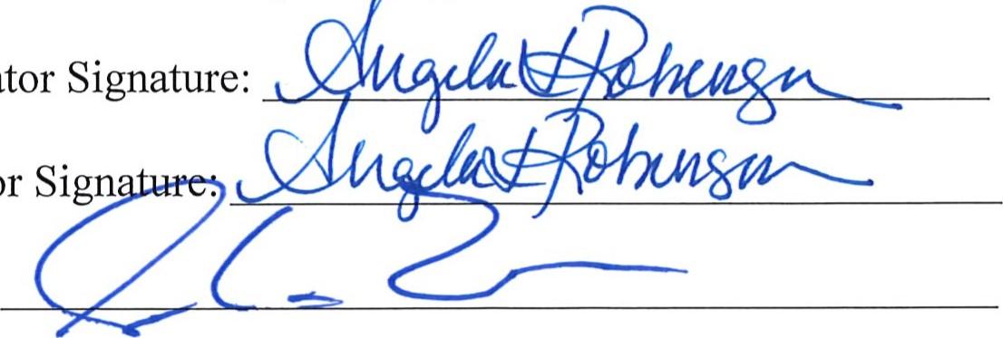
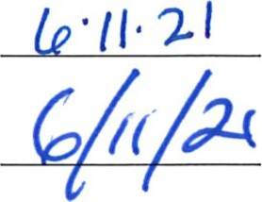
Date: (p • // • 21 Language Access Coordinator Signature:
Date: District Court Administrator Sign
Date:President Judge Signature:

Id. at 4-5, available at http://languageaccess.pacourts.us.
Language Access Plan for the Unified Judicial System of Pennsylvania at 5-7, available at http://languageaccess.pacourts.us.
Pa. Code 5221.
See also Section V(A)(I), Language Services and How to Use Them/Oral Language Services/lnterpreters at 10-13, and Section V111(1) Qualification Requirements for Interpreters and Translators, at 33-35, respectively, of the LAP-UJS, which are hereby incorporated by reference.
The District must provide an interpreter to deaf and hard of hearing court users whether parties to a case, witnesses, family members, or spectators. Interpreters are also provided to limited English proficient fiduciaries for a party; and a parent, guardian, or custodian of a minor or incapacitated person who is a party, victim, or witness. ⁷ http://www.pacourts.us/judicial-administration/court-programs/interpreter-program
see 204 Pa. Code ch. 221 5104.
http://www.pacourts.us/forms/bilingual-forms
A checklist of considerations and suggestions regarding bi- and multilingual signage in courthouses and websites was provided to the judicial districts on March 14, 2019.
See, Section IX, Training, below. Judicial district employees have been trained in the appropriate use of telephone interpreting, and know that its best use is for brief encounters at the counter, rather than judicial proceedings, per Section 104 of the regulations pursuant to the Interpreter Act.
See, Guidance on Services beyond the Courtroom provided to the judicial districts on March 14, 2019.
For example, language similar to the following could be used: Vendor will comply, and all its subcontractors will comply, with the nondiscrimination requirements of the Civil Rights Act of 1870; Title VI of the Civil Rights Act of 1964; Section 504 of the Rehabilitation Act of 1973; Subtitle A, Title Il of the Americans with Disabilities Act (ADA) (1990); Title IX of the Education Amendments of 1972; Regulations implementing Sections 799A and 845 of the Public Health Service Act, 45 C.F.R. Part 83; the Age Discrimination Act of 1975; and 45 C.F.R. Parts 83, 84, 86, and 90, as well as any other applicable federal nondiscrimination statutes and regulations. Specifically, Vendor must provide foreign language interpreters and translated documents to limited English proficient participants in compliance with Title VI of the federal Civil Rights Act, and sign language interpreters to deaf or hard of hearing participants in compliance with the Americans with Disabilities Act.

